|  |  |  |  |  |
| --- | --- | --- | --- | --- |
|  | January | February | March | Total |
| BOPHA | 326 | 310 | 300 | 936 |
| ROMDOUL | 316 | 3320 | 300 |
| PISEY | 412 | 390 | 350 | 1152 |
| RATHA | 310 | 326 | 330 | 966 |
| PANHA | 400 | 390 | 390 | 1180 |
| SOK | 516 | 480 | 300 | 1481 |

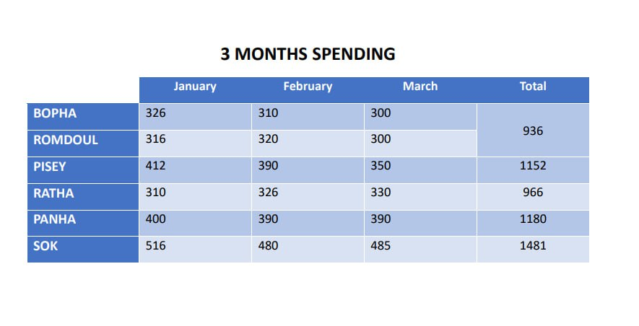**3 MONTHS SPENDING**